Exercise 2

Libraries and Frameworks

JavaScript frameworks and libraries are a set of pre built functions, methods or controls, these are then used to produce code much more efficiently rather than building a complete website from nothing these tools can be used to carry out required actions by the website. When looking I realised frameworks and libraries are often both used at the same time and are very closely linked however the main defining factor is JavaScript libraries are used to carry out very specific tasks and have a clearly defined purpose whereas JavaScript frameworks are set out as code with the basis their and then this is able to be adapted by the user to fulfil the required purpose. There is however a lot of grey area between what can be classed as a framework and what is classed as a library

BHive

Bhive was created to help make programming easier for beginner or inexperienced game developers and animators as it reduces the learning curve required to learn how to program their games and animations as it provides an array of functions that the game developer is then able to call in their game to carry out the action they want, with this as well once developers get more experienced they can then do more with the framework adapting how each function works in the game or animation and later program their own games from scratch. It can be used from creating simple drawings right the way up to being able to create fun animations with added interactivity

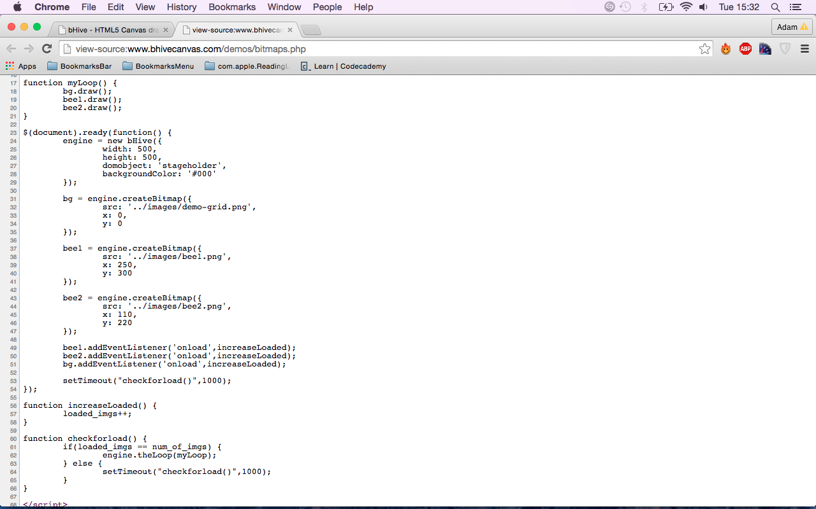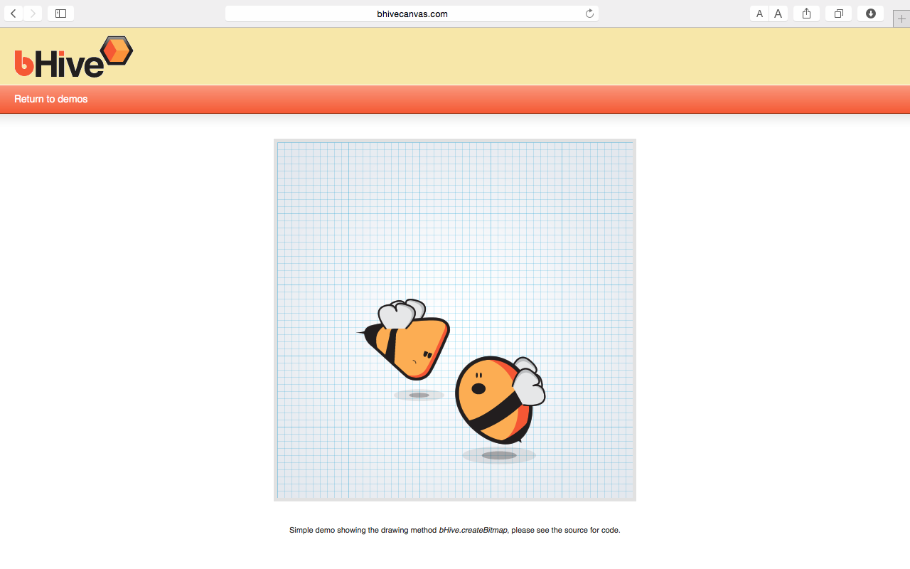BHive has been used to develop static drawings such as the image shown below along with a section of the code and this shows the BHive draw capabilities and it also used the onload event handler

BHive can also be used for more complex animations such as this shown below as seen the cloud is able to move, and the character is able to move along the background and it also has the extra interactivity of the character being able to jump on the mouse being clicked and the code is shown below

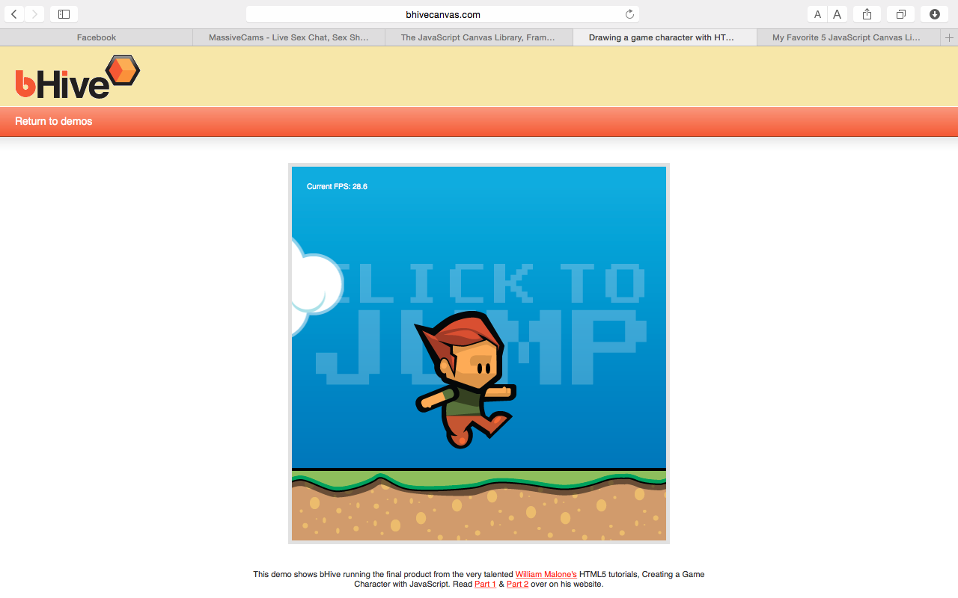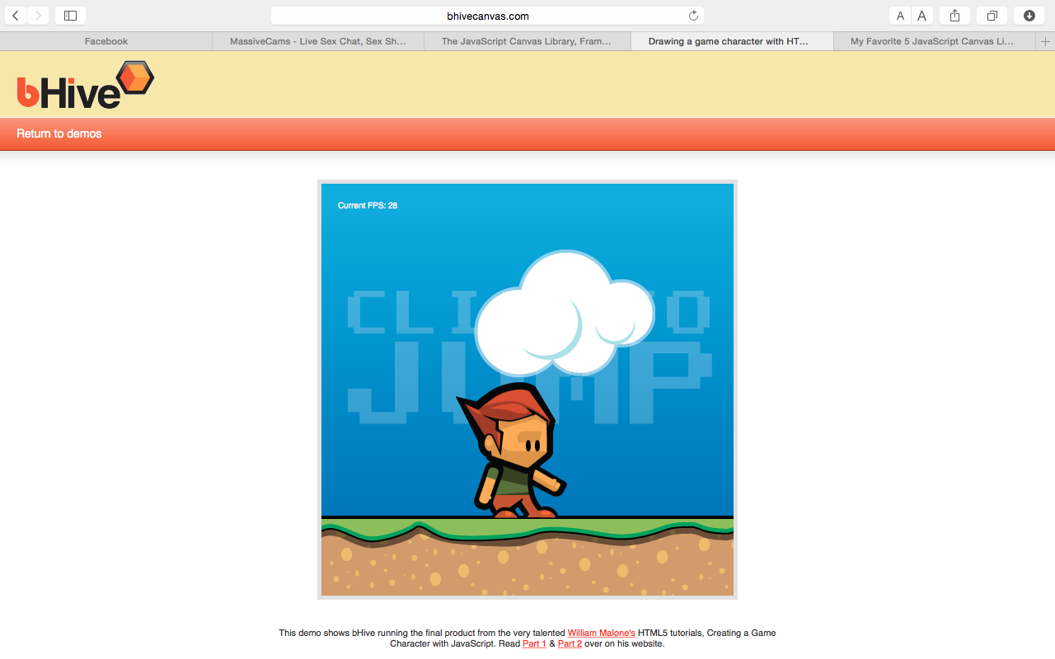

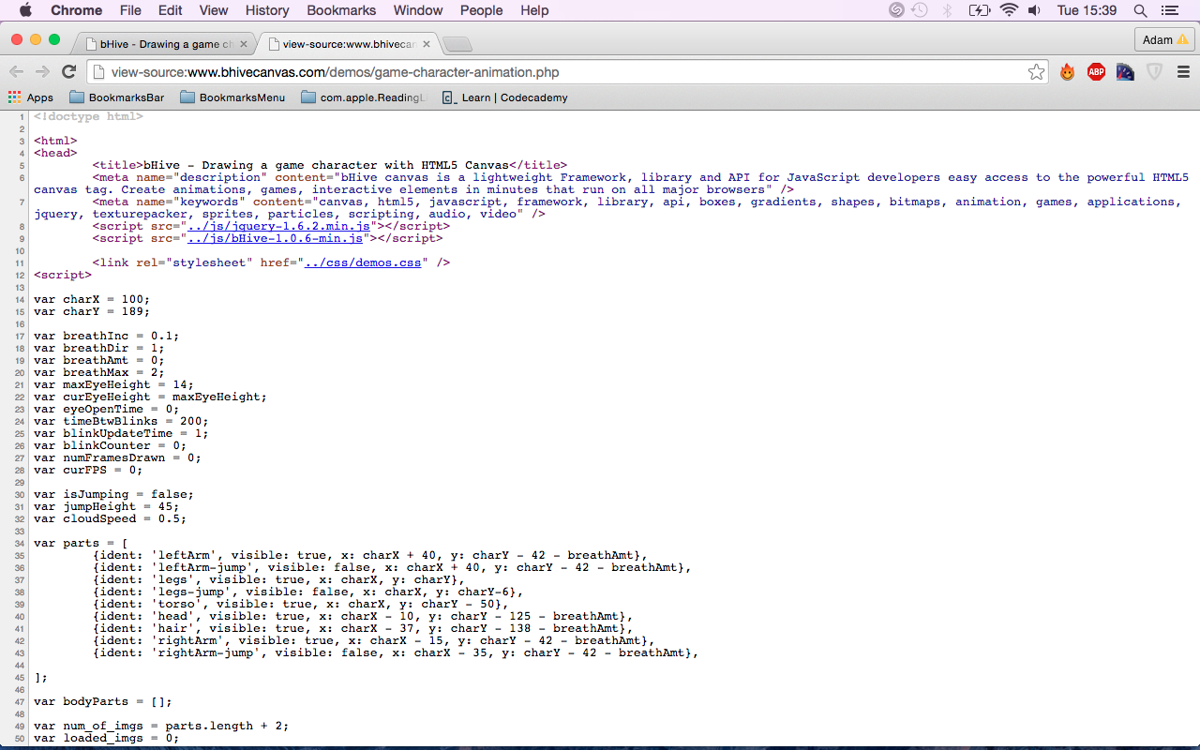

Bhive has three main features it can be used to draw basic shapes to freehand shapes which aren’t so uniform to adding in gradient backgrounds and various fill styles.

BHive can animate shapes and image objects; It can also carry out scaling, transparency and rotation.

Lastly BHive is able to carry out interactivity of sprites such as mouse click events or use keyboard buttons to carry out various different functions

It has become popular because of its ease of use in helping animators and games developers in getting started as they don’t have to start from nothing this helps in making it easier for them to learn and therefore makes the learning experience of young game developers and animators more enjoyable and less frustrating as they can use pre made functions to help what they are making rather than having to make there own. This is not only easier but also it means that they get results faster so rather than having to be patient users are quickly able to see what they have made. As a result of this it is then quite quick and easy for beginners to use before they are then able to go on and make their own animations and games

The main disadvantages are that some people may not improve their skills as significantly as they may just use the functions in the framework but not look at how they work and how they can then be modified. Also developing with BHive will be much quicker and cause less to break so then for those trying to leave BHive to make their own games and animations with the functions available it may be a frustrating and unenjoyably experience because of work breaking and not being able to fix the issue

Github history report shown below

